Java FSE – Hands on Assignment

Name: Angarag Seal
Email: angaragseal55@gmail.com
Week -5
React-1
Create a new React Application with the name “myfirstreact”, Run the application to print “welcome to the first session of React” as heading of that page.
- To create a new React app, Install Nodejs and Npm from the following link:
https://nodejs.org/en/download/
- Install Create-react-app by running the following command in the command prompt:

- To create a React Application with the name of “myfirstreact”, type the following command:

- Once the App is created, navigate into the folder of myfirstreact by typing the following command:
- Open the folder of myfirstreact in Visual Studio Code
- Open the App.js file in Src Folder of myfirstreact
- Remove the current content of “App.js”
- Replace it with the following:

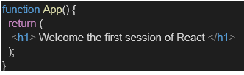

- Run the following command to execute the React application:

- Open a new browser window and type “localhost:3000” in the address bar

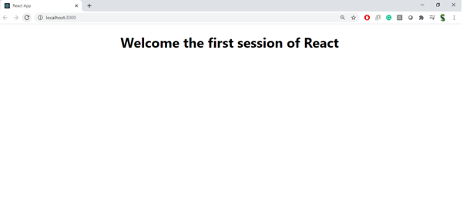

Output:
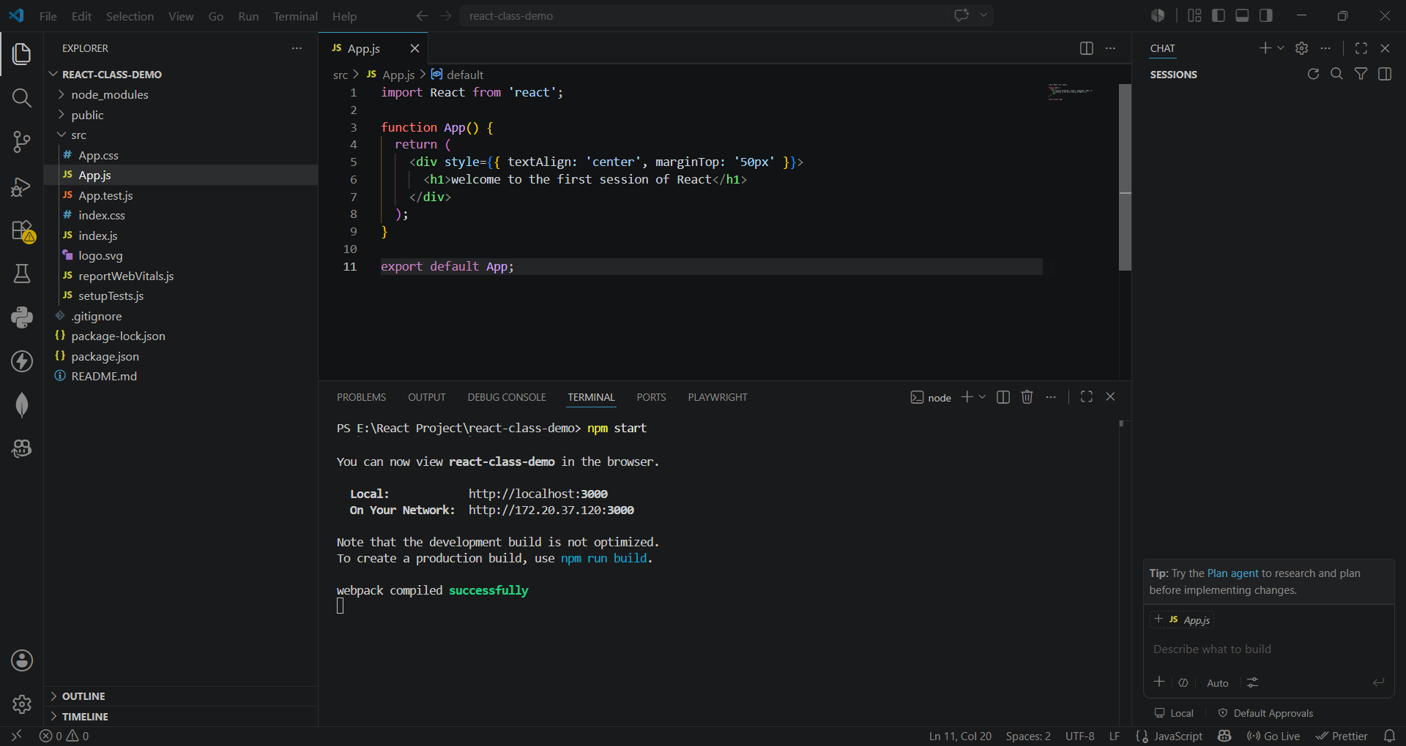
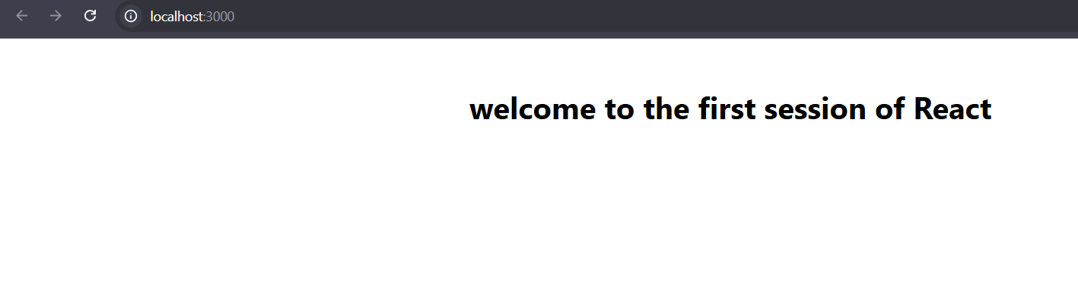

React-2

- Create a React project named “StudentApp” type the following command in terminal of Visual studio:

- Create a new folder under Src folder with the name “Components”. Add a new file named “Home.js”

- Type the following code in Home.js

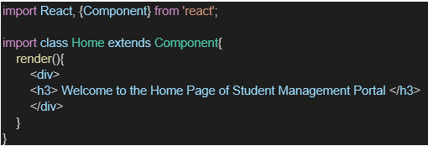

- Under Src folder add another file named “About.js”

- Repeat the same steps for Creating “About” and “Contact” component by adding a new file as ”About.js”, “Contact.js” under “Src” folder and edit the code as mentioned for “Home” Component.

- Edit the App.js to invoke the Home, About and Contact component as follows:

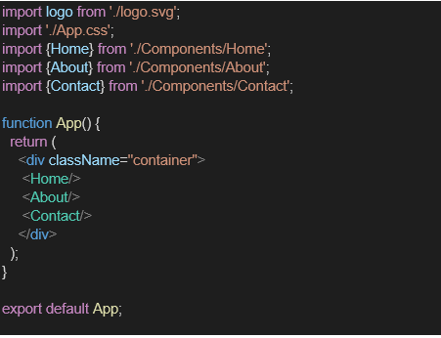

- In command Prompt, navigate into StudentApp and execute the code by typing the following command:

- Open browser and type “localhost:3000” in the address bar:

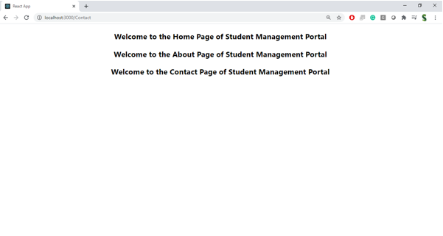

Output:
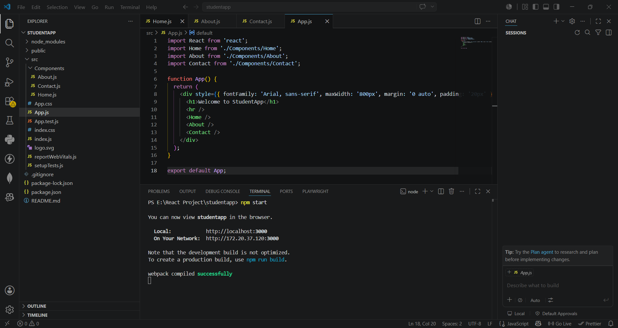

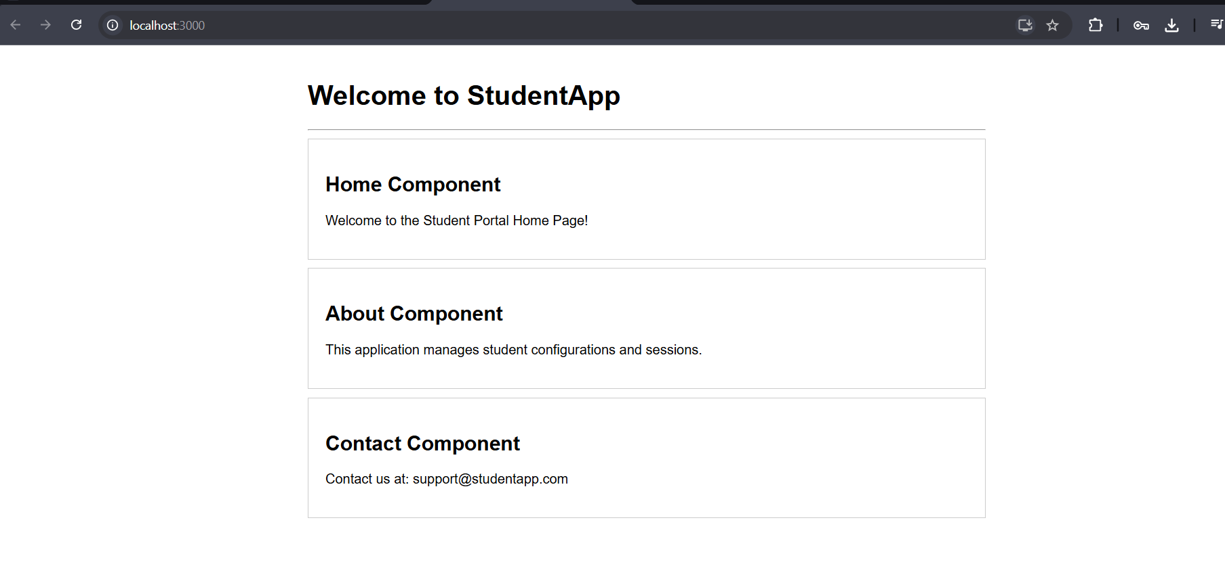

React-3
Create a react app for Student Management Portal named scorecalculatorapp and create a function component named “CalculateScore” which will accept Name, School, Total and goal in order to calculate the average score of a student and display the same.

- Create a React project named “scorecalculatorapp” type the following command in terminal of Visual studio:

- Create a new folder under Src folder with the name “Components”. Add a new file named “CalculateScore.js”

- Type the following code in CalculateScore.js

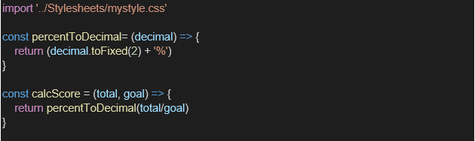
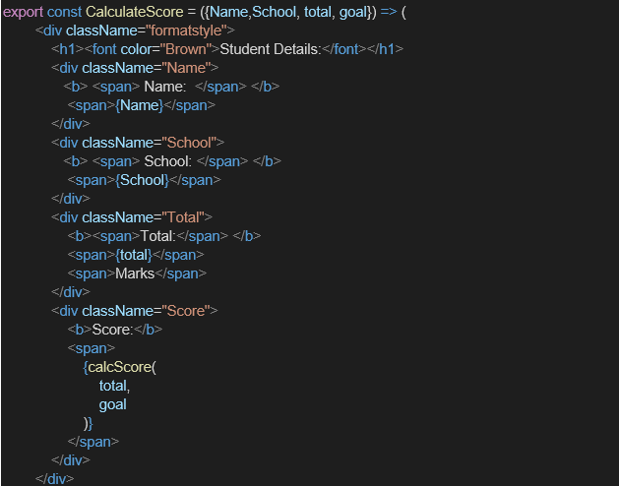

- Create a Folder named Stylesheets and add a file named “mystyle.css” in order to add some styles to the components:

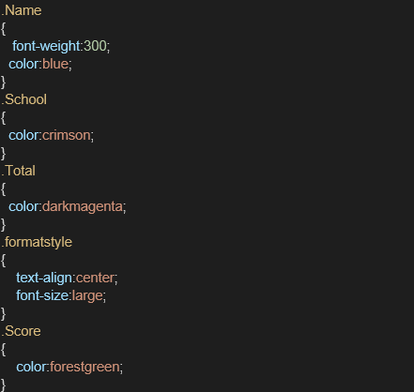

- Edit the App.js to invoke the CalculateScore functional component as follows:

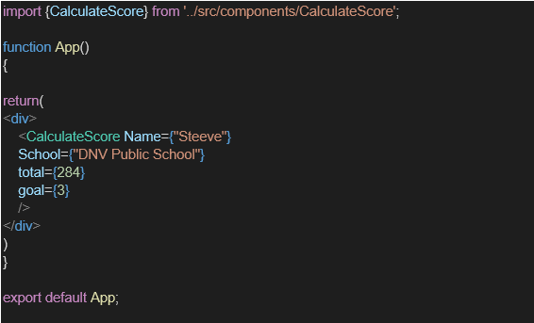

- In command Prompt, navigate into scorecalculatorapp and execute the code by typing the following command:

- Open browser and type “localhost:3000” in the address bar:

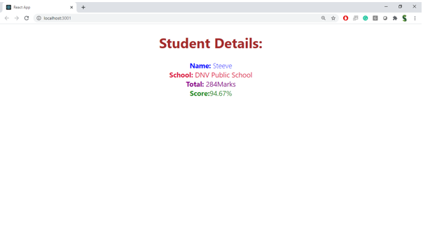

Output:
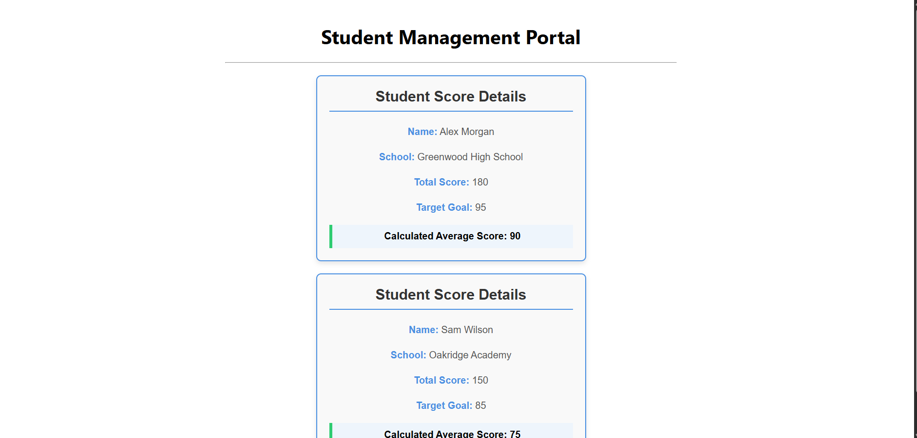

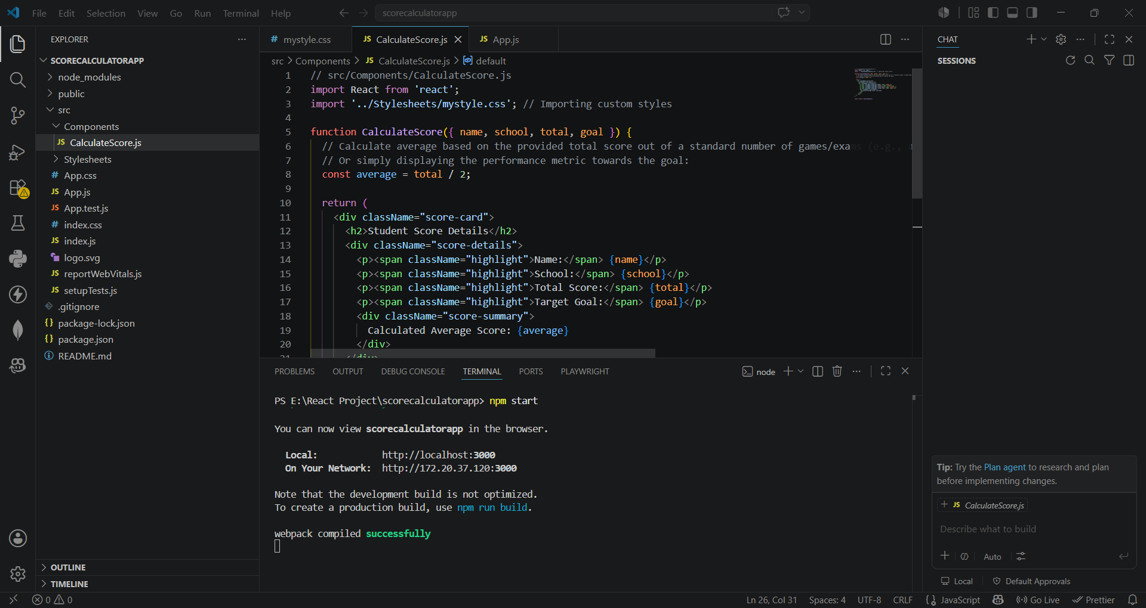

React-4

- Create a new react application using create-react-app tool with the name as “blogapp”
- Open the application using VS Code
- Create a new file named as Post.js in src folder with following properties

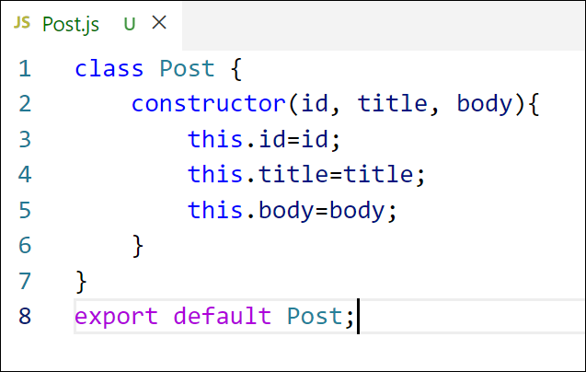
Figure 2: Post class
- Create a new class based component named as Posts inside Posts.js file
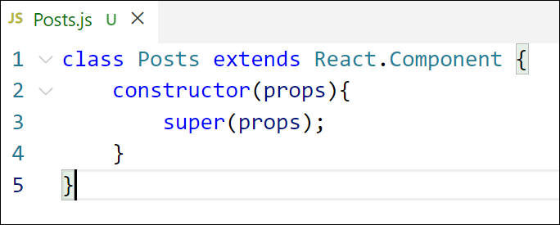
Figure 3: Posts Component
- Initialize the component with a list of Post in state of the component using the constructor
- Create a new method in component with the name as loadPosts() which will be responsible for using Fetch API and assign it to the component state created earlier. To get the posts use the url (https://jsonplaceholder.typicode.com/posts)

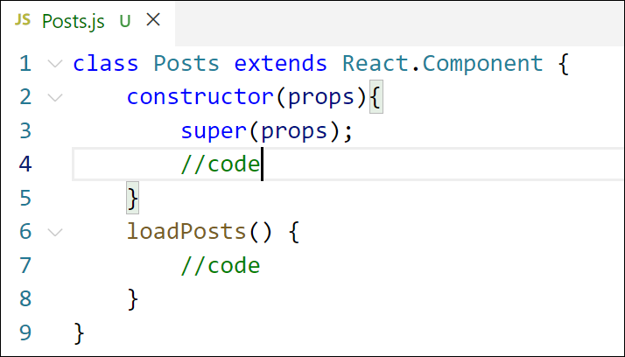
Figure 4: loadPosts() method
- Implement the componentDidMount() hook to make calls to loadPosts() which will fetch the posts

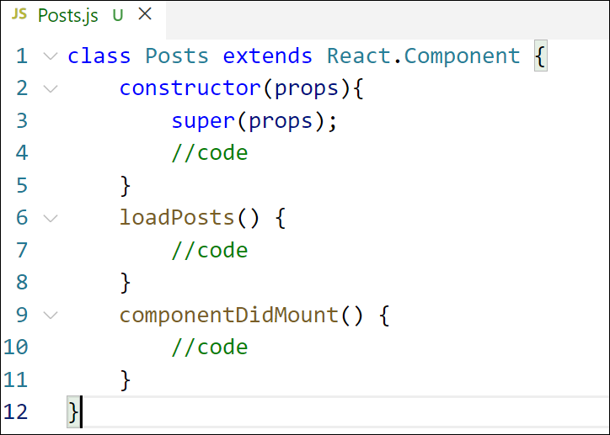
Figure 5: componentDidMount() hook
- Implement the render() which will display the title and post of posts in html page using heading and paragraphs respectively.

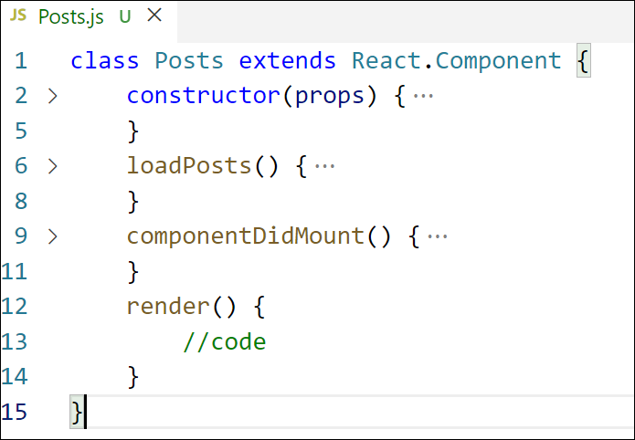
Figure 6: render() method
- Define a componentDidCatch() method which will be responsible for displaying any error happing in the component as alert messages.

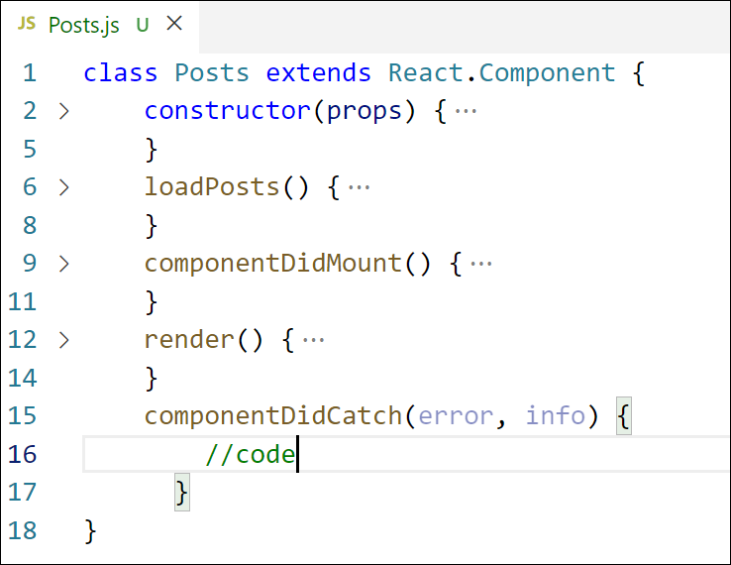
Figure 7: componentDidCatch() hook
- Add the Posts component to App component.
- Build and Run the application using npm start command.

Output:
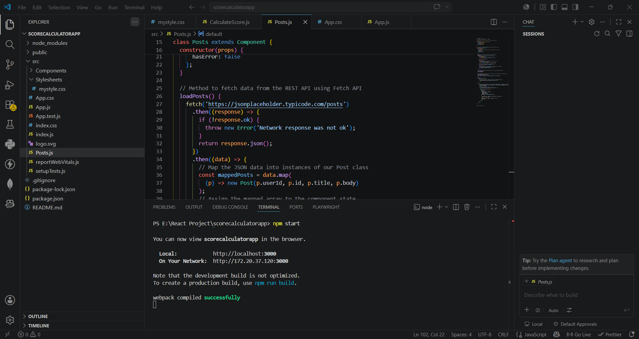
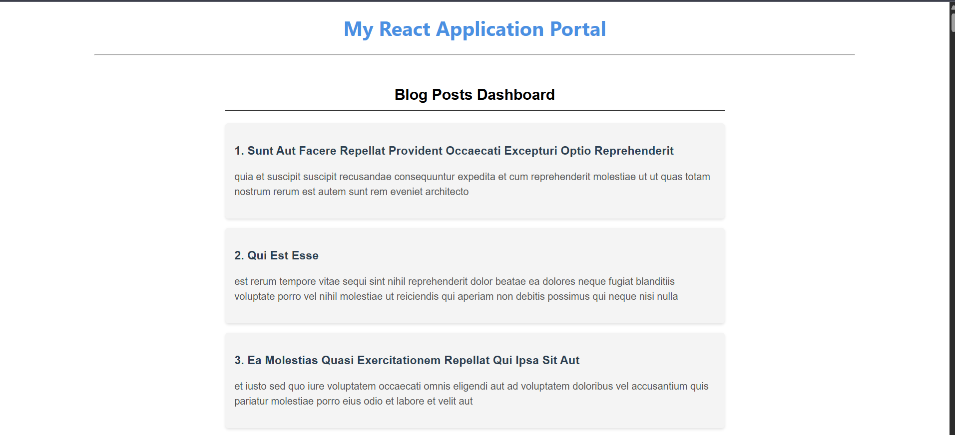
React-5

My Academy team at Cognizant want to create a dashboard containing the details of ongoing and completed cohorts. A react application is created which displays the detail of the cohorts using react component. You are assigned the task of styling these react components.
Download and build the attached react application.
- Unzip the react application in a folder
- Open command prompt and switch to the react application folder
- Restore the node packages using the following commands
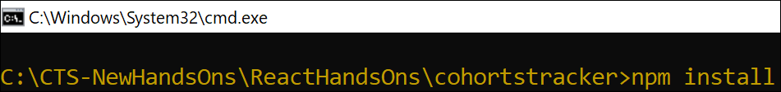
Figure 1: Restore packages
- Open the application using VS Code
- Create a new CSS Module in a file called “CohortDetails.module.css”
- Define a css class with the name as “box” with following properties
Width = 300px;
Display = inline block;
Overall 10px margin
Top and bottom padding as 10px
Left and right padding as 20px
1 px border in black color
A border radius of 10px
- Define a css style for html <dt> element using tag selector. Set the font weight to 500.
- Open the cohort details component and import the CSS Module
- Apply the box class to the container div
- Define the style for <h3> element to use “green” color font when cohort status is “ongoing” and “blue” color in all other scenarios.
- Final result should look similar to the below image

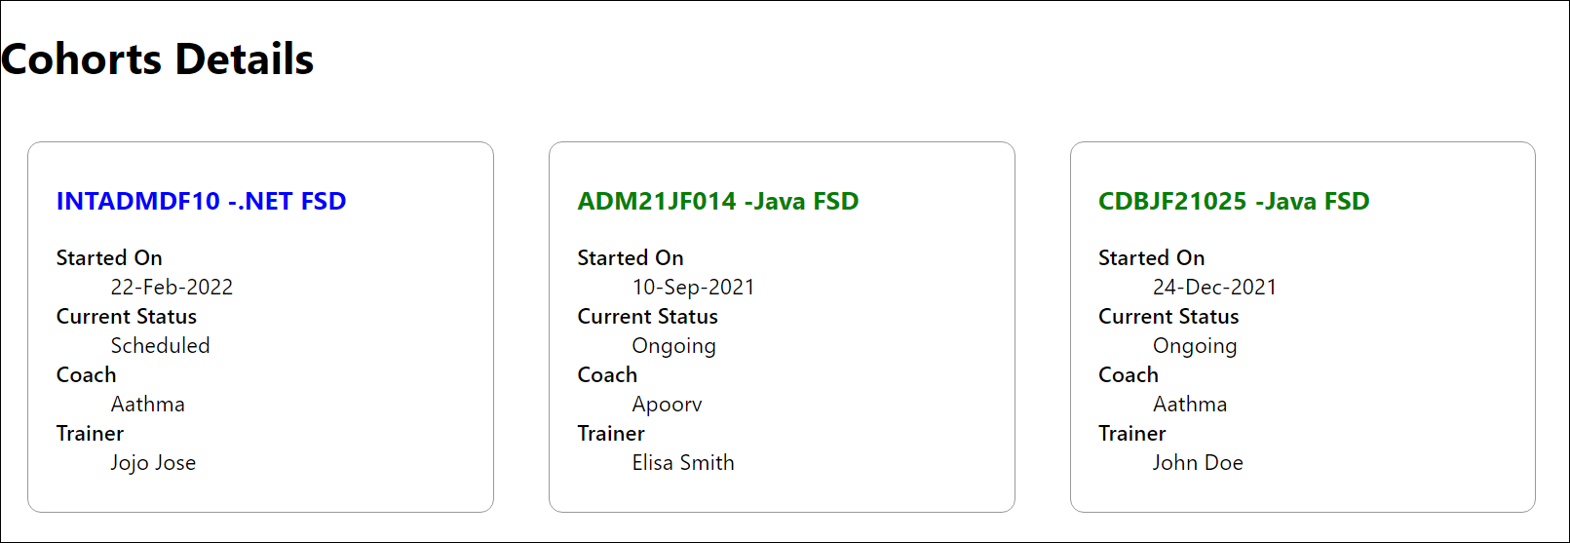
Figure 2: Final Result
Output:
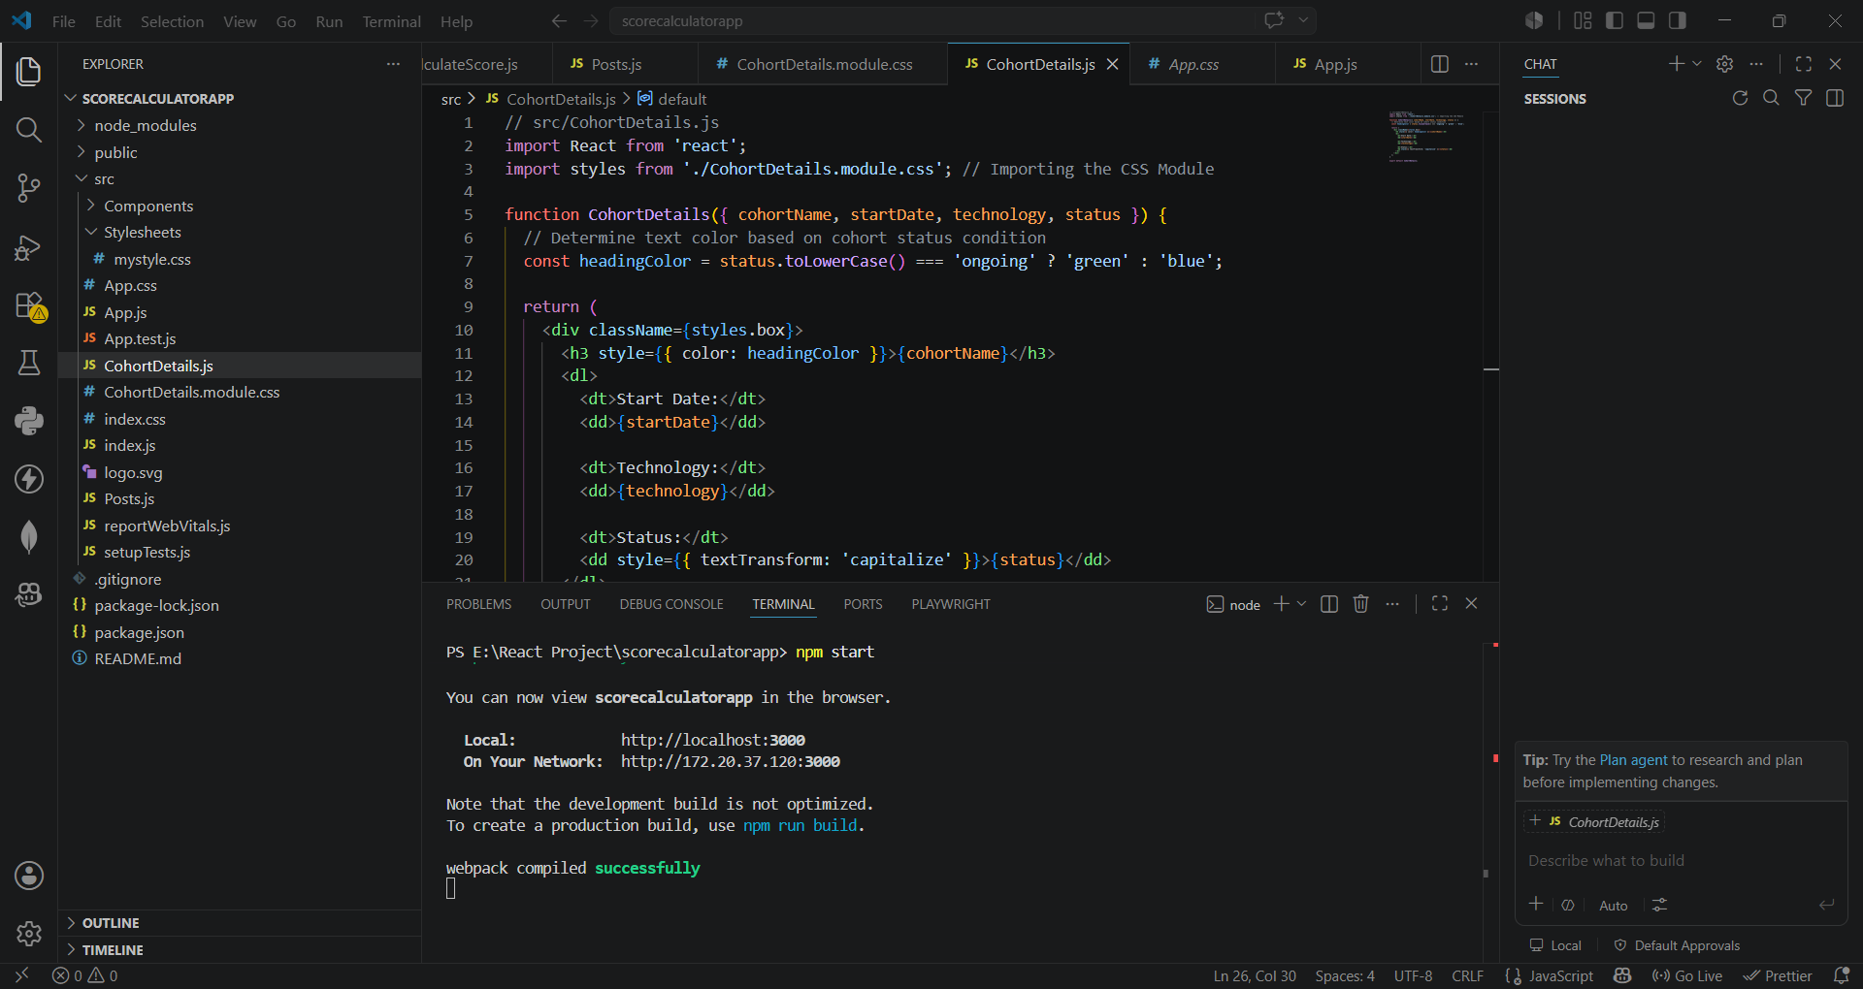
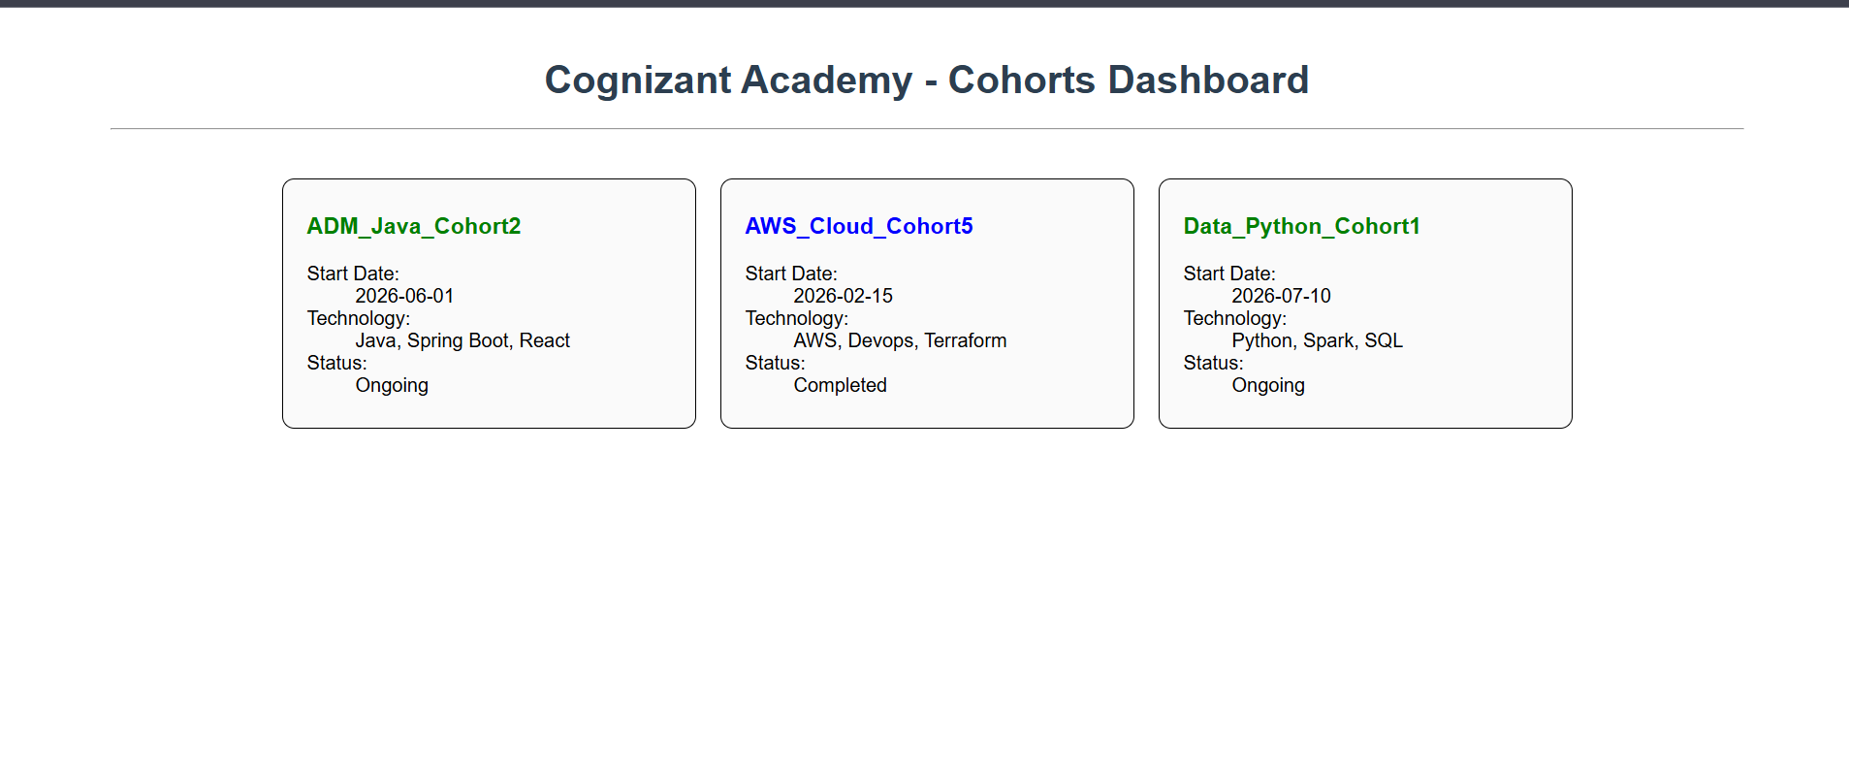

React-9
Create a React Application named “cricketapp” with the following components:
- ListofPlayers
- Declare an array with 11 players and store details of their names and scores using the map feature of ES6

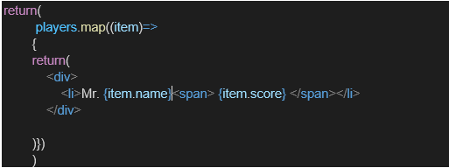

- Filter the players with scores below 70 using arrow functions of ES6.

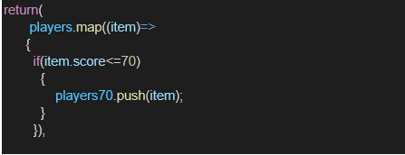

- IndianPlayers

  - Display the Odd Team Player and Even Team players using the Destructuring features of ES6
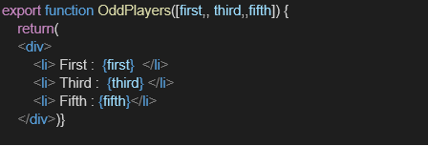

  - Declare two arrays T20players and RanjiTrophy players and merge the two arrays and display them using the Merge feature of ES6
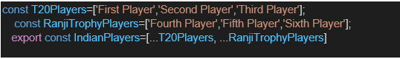

Display these two components in the same home page using a simple if else in the flag variable.
Output:
When Flag=true
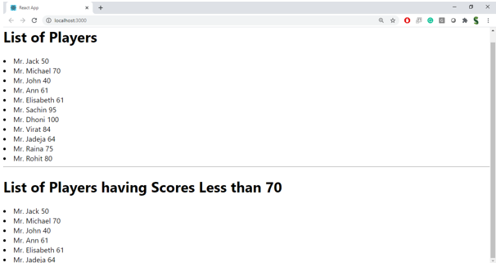

When Flag=false

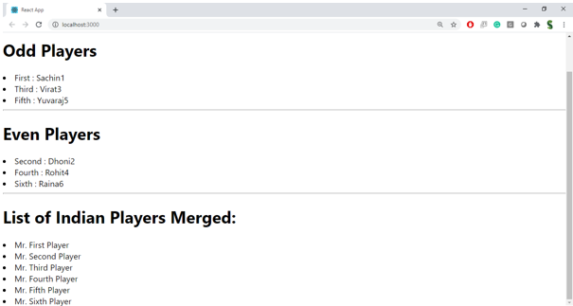

Output:
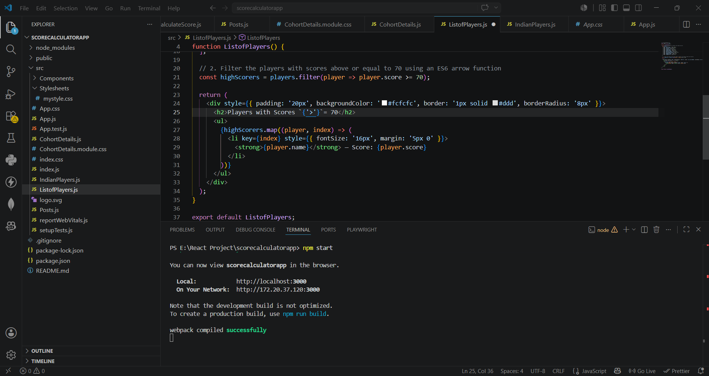
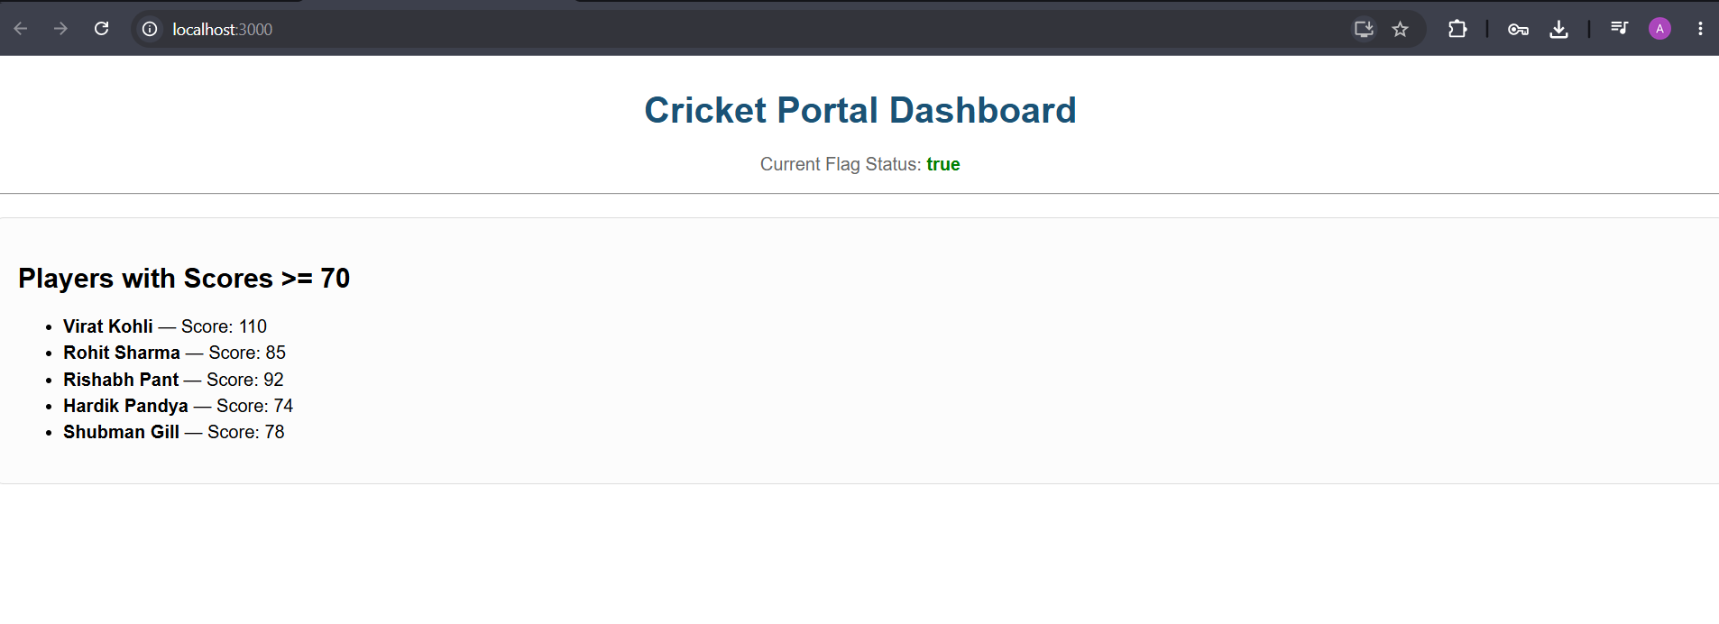
React-10
Create a React Application named “officespacerentalapp” which uses React JSX to create elements, attributes and renders DOM to display the page.

Create an element to display the heading of the page.
Attribute to display the image of the office space
Create an object of office to display the details like Name, Rent and Address.
Create a list of Object and loop through the office space item to display more data.
To apply Css, Display the color of the Rent in Red if it’s below 60000 and in Green if it’s above 60000.

Output:
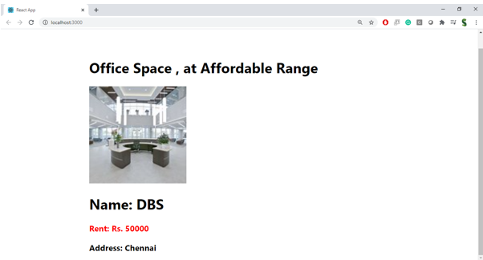

Hint:
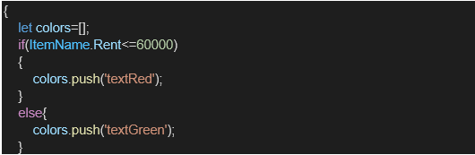
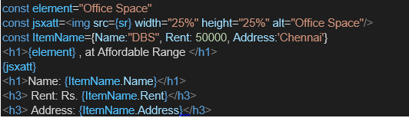

Output:
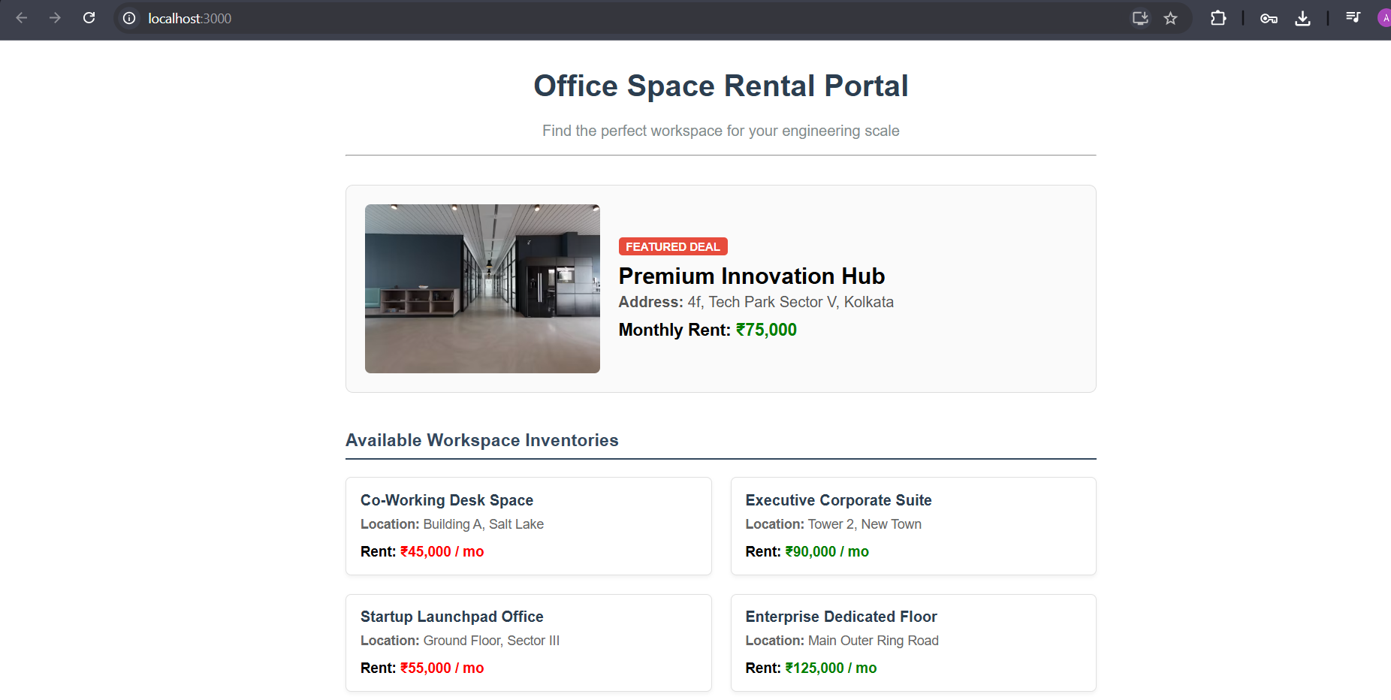
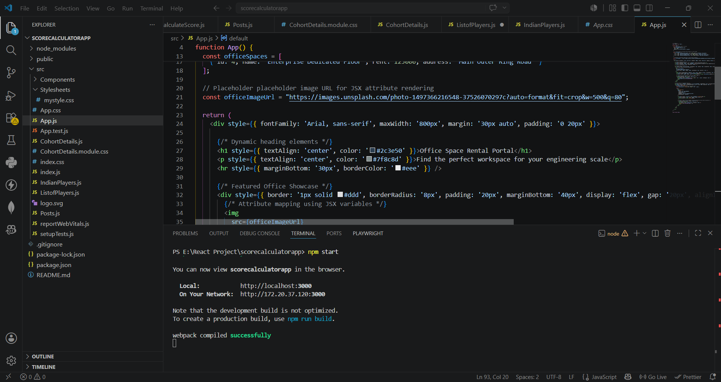
React-11

Create a React Application “eventexamplesapp” to handle various events of the form elements in HTML.

- Create “Increment” button to increase the value of the counter and “Decrement” button to decrease the value of the counter. The “Increase” button should invoke multiple methods.
  - To increment the value
  - Say Hello followed by a static message.
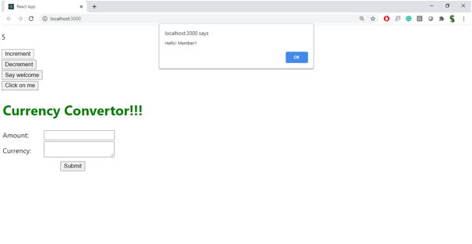

- Create a button “Say Welcome” which invokes the function which takes “welcome” as an argument.

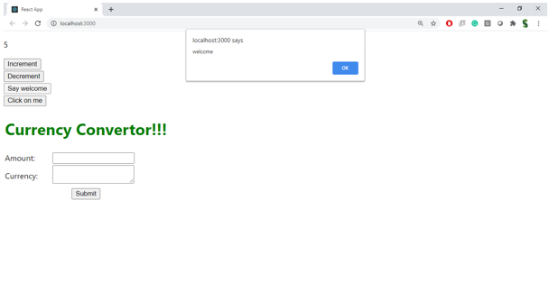

- Create a button which invokes synthetic event “OnPress” which display “I was clicked”

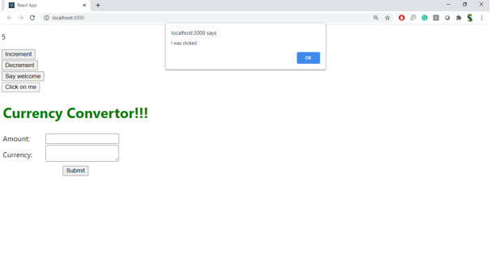

Create a “CurrencyConvertor” component which will convert the Indian Rupees to Euro when the Convert button is clicked.

Handle the Click event of the button to invoke the handleSubmit event and handle the conversion of the euro to rupees.

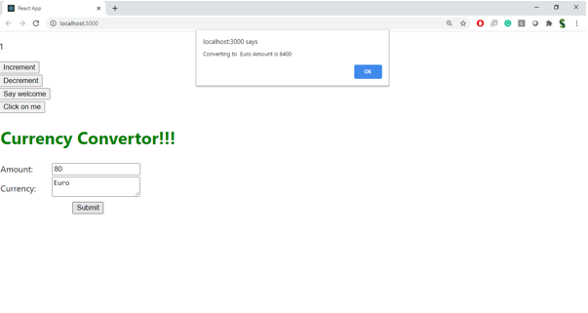

Output:
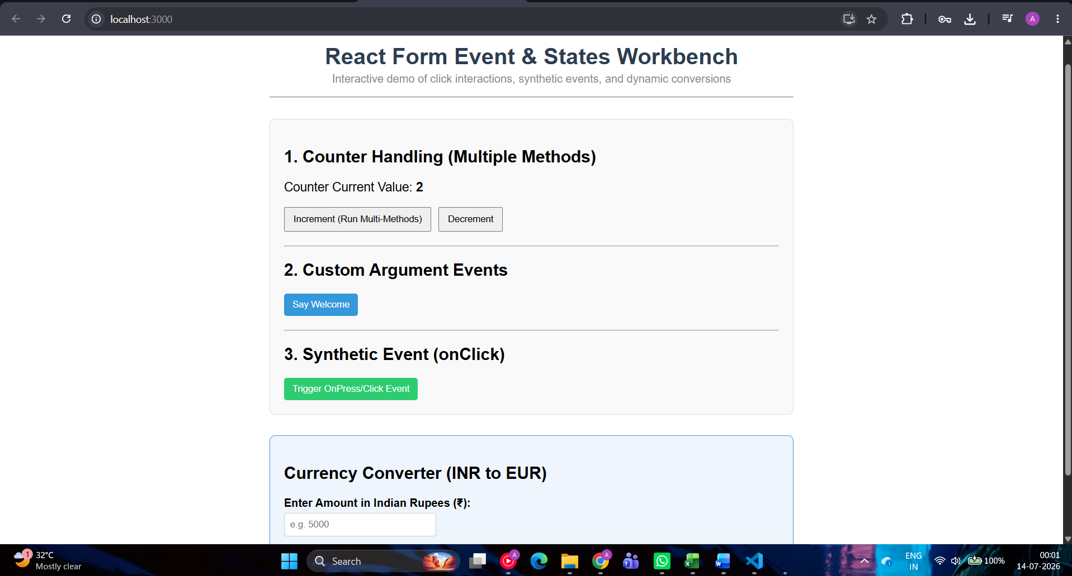
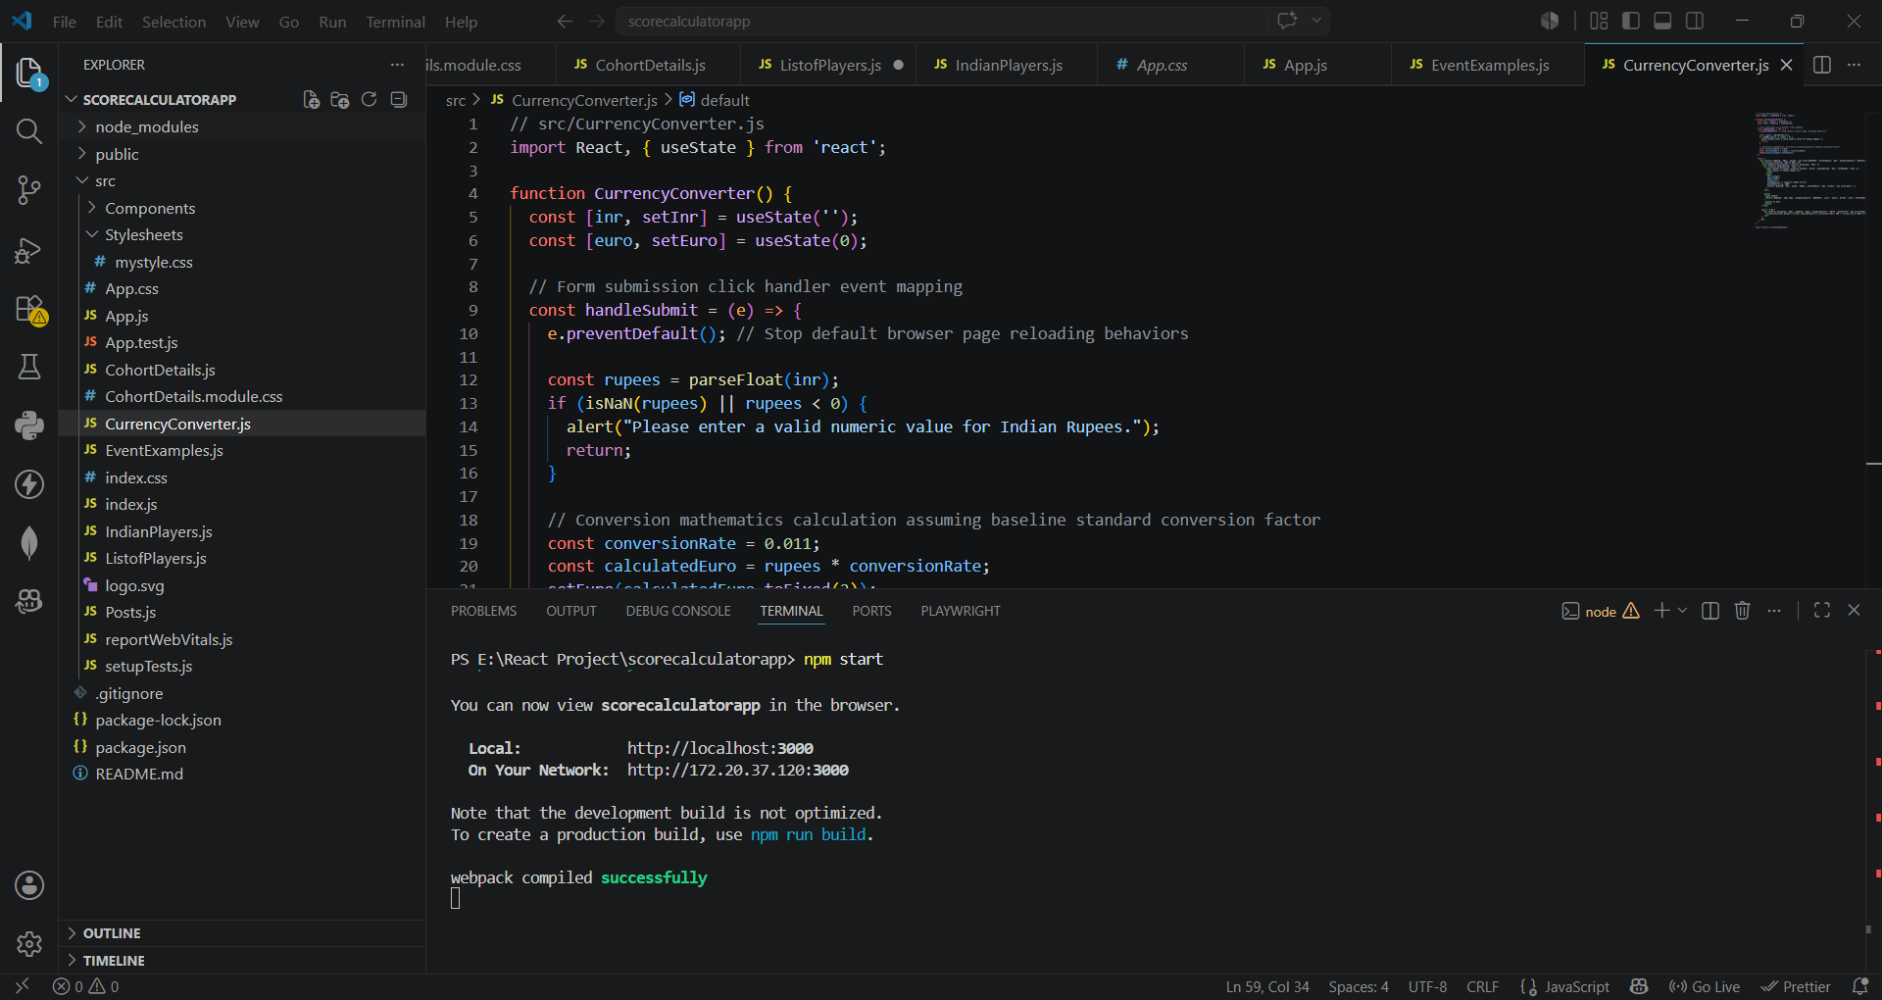
React-12
Create a React Application named “ticketbookingapp” where the guest user can browse the page where the flight details are displayed whereas the logged in user only can book tickets.

The Login and Logout buttons should accordingly display different pages. Once the user is logged in the User page should be displayed. When the user clicks on Logout, the Guest page should be displayed.

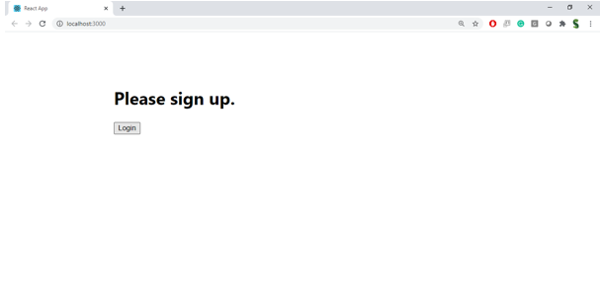

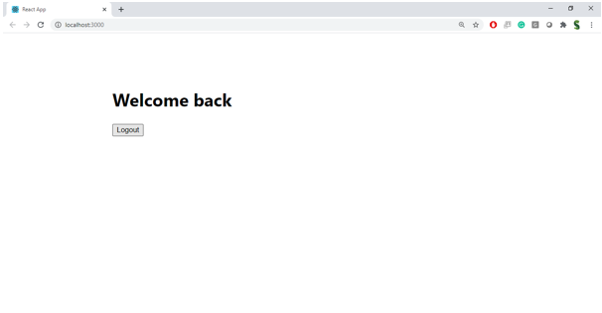

Hint:

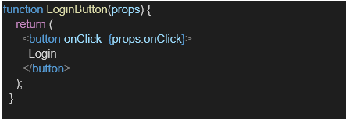
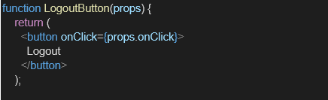

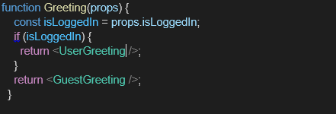

Output:
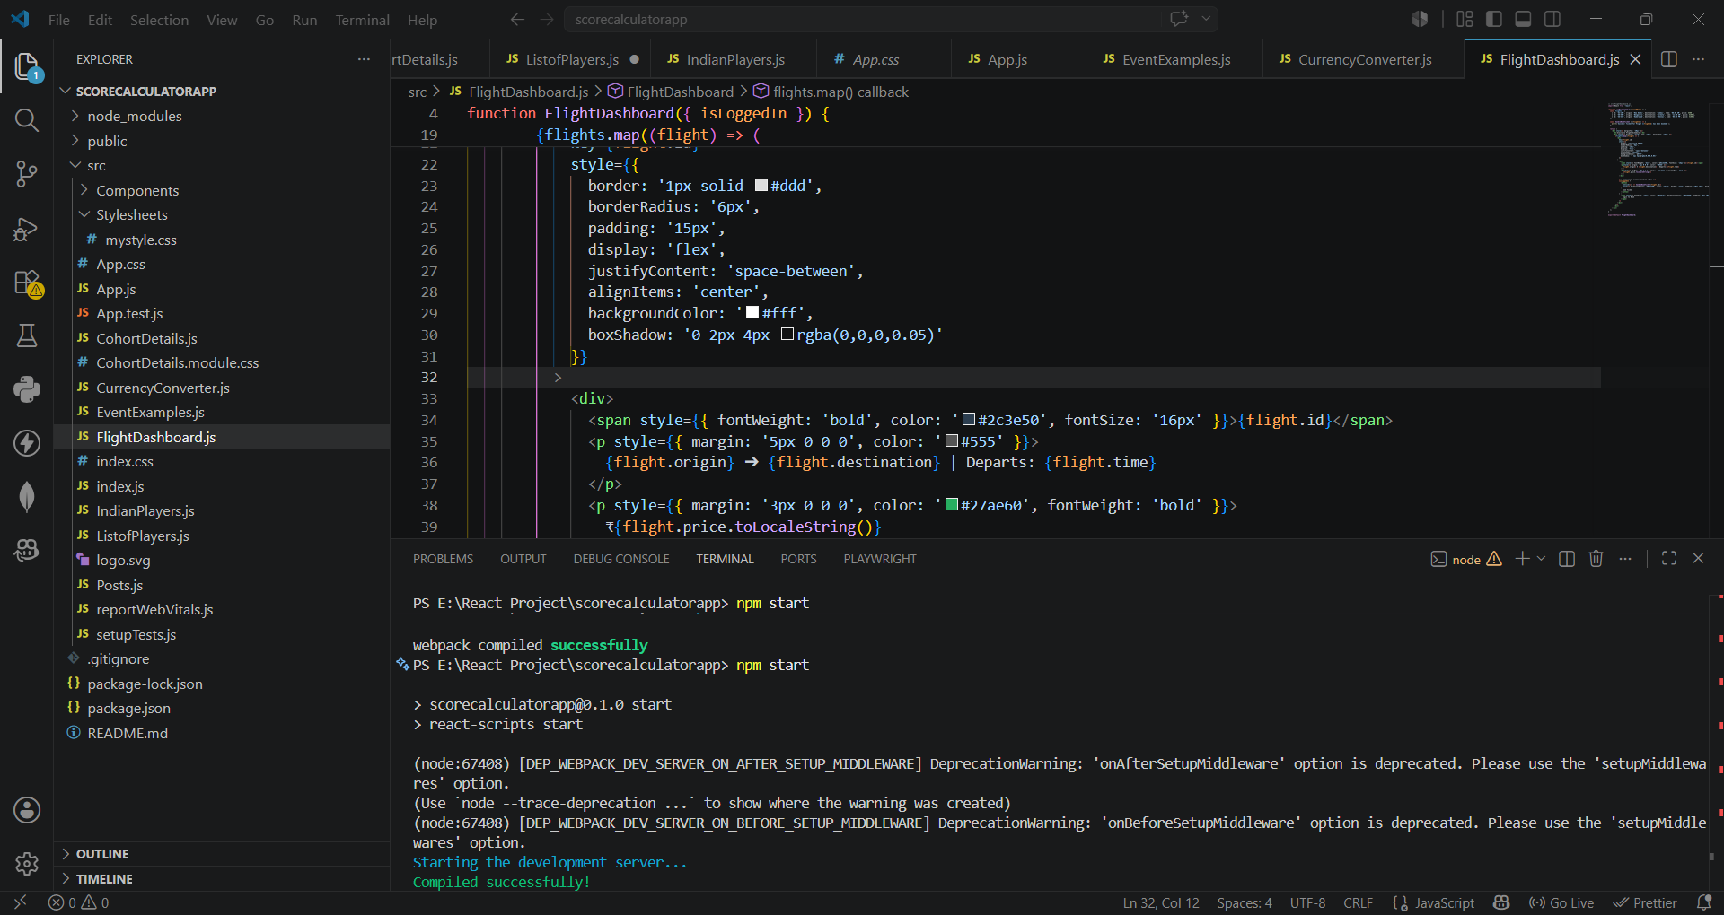
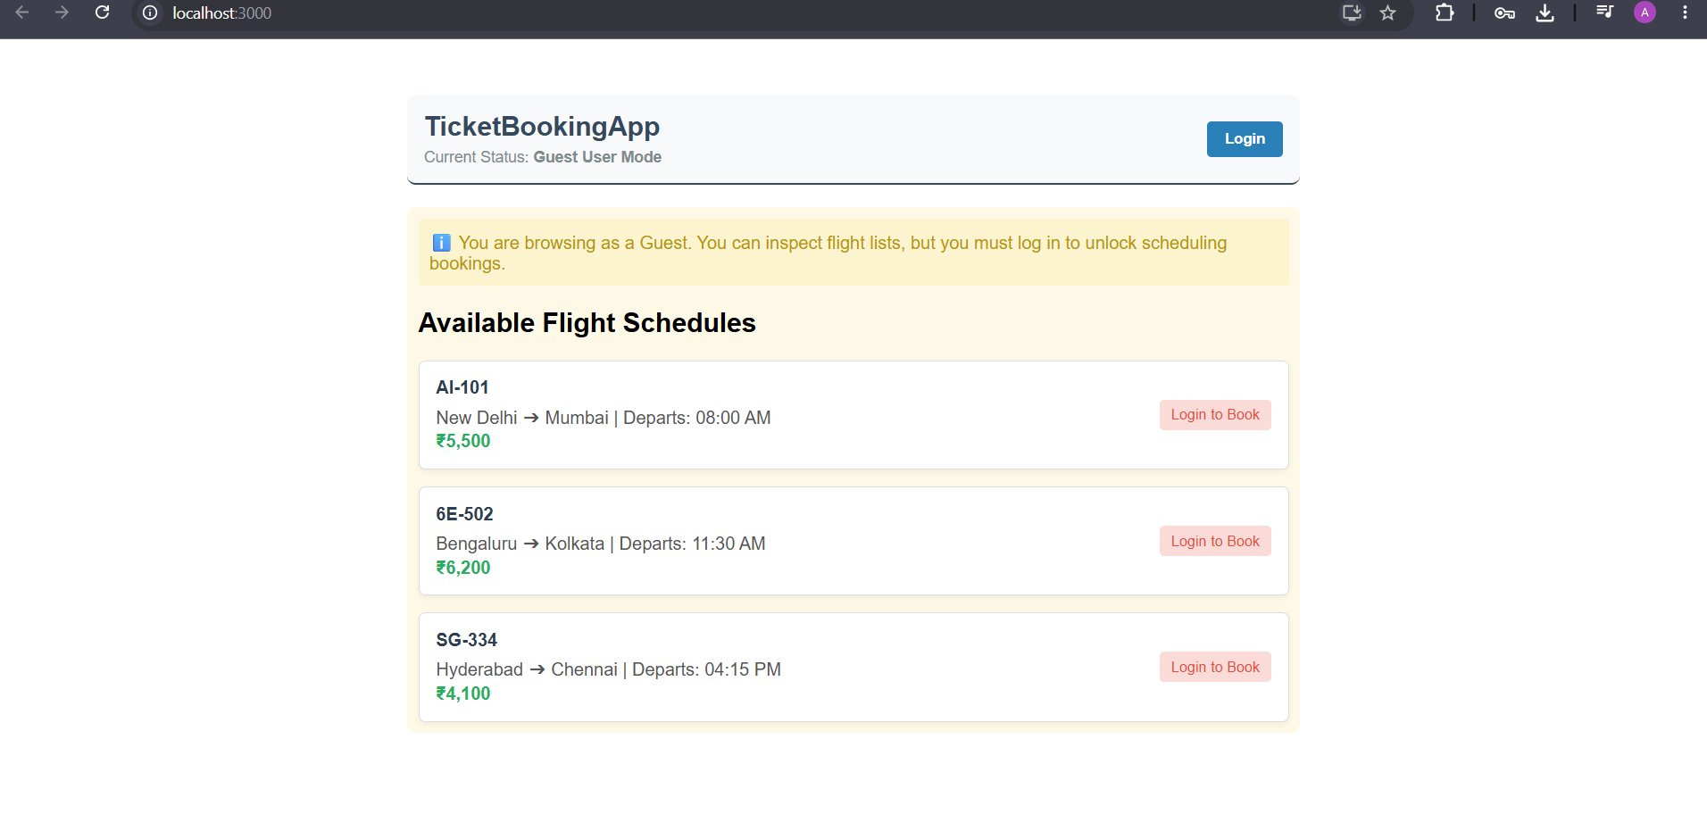
React-13
Create a React App named “bloggerapp” in with 3 components.

- Book Details
- Blog Details
- Course Details

Implement this with as many ways possible of Conditional Rendering.

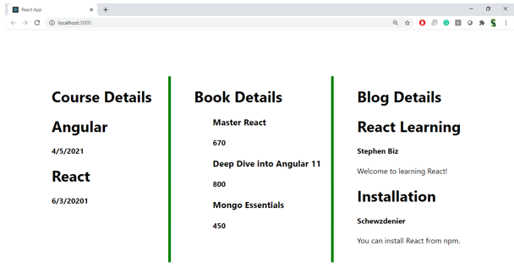

Hint:

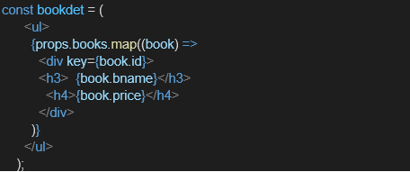

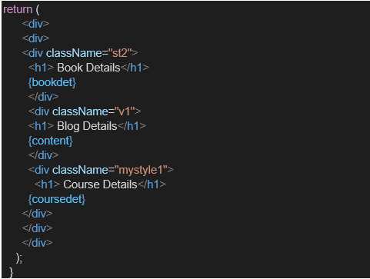

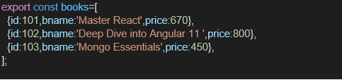

Output:
